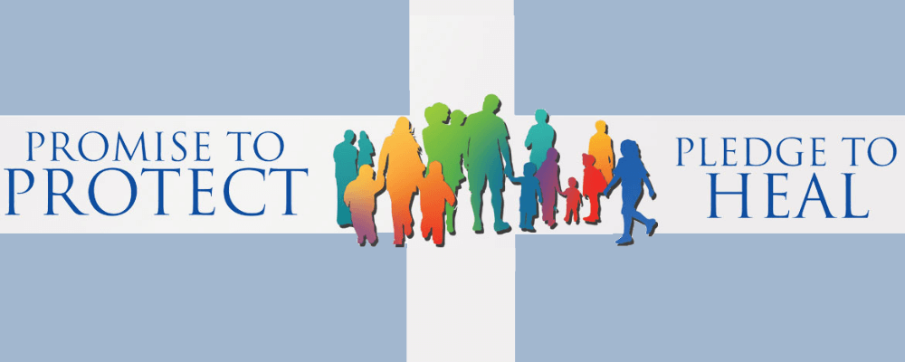
St. Fidelis Safe Environment Release Form
Please list all children enrolled in Religious Education at St. Fidelis including full name and grade level during 22-23 year:

﻿The children’s K-12 Religious Education Safe Environment program consists of age-appropriate lessons built upon the Church’s teaching that “the human body shares in the dignity of the image of God” (CCC 364). That dignity leads us to foster in every person the belief and awareness that as a person of God they are deserving of love and respect. Because dignity is a gift given by God at birth, abuse of all kinds is harmful to that dignity. Children being among the most vulnerable require us to protect that dignity.
​
The Diocese of Salina has asked that each catechist spend time with their class on an annual basis reviewing ways your child can protect themselves, what healthy boundaries look like and encouraging safety measures as well as actions that can be taken to keep one another safe. This will look differently for each grade level as the subjects discussed are focused on the age of the child, maturity and what areas most affect them.
​
Parental permission is requested for your child(ren) to participate. Please check what is applicable to you and your family and submit at the time of enrollment.

Yes, I give my consent for my child(ren) to participate in the annual Safe Environment training program.

No, I do not give my consent for my child(ren) to participate in the Safe Environment training program. On the day this lesson is presented, my child(ren) will not attend religious education class.

No, I do not give consent. I will meet with the Religious Education Coordinator and make a decision at that time. I understand that without written consent, my child(ren) may not attend religious education classes on the day this lesson is presented.

Parent’s signature: ____________________________________________________ Date: ___________
Parent’s name (printed if not signed electronically):__________________________________________

